Name: Class:
Introduction
A supercritical fluid is any substance at a temperature and pressure above its critical point. The highest temperature at which a substance can be liquefied is its critical temperature. The pressure that must be supplied at this temperature to bring about liquefaction is its critical pressure. Together, this critical temperature and pressure define the critical point of a substance. At the critical point, the distinction between gas and liquid does not apply, and the substance can only be described as a fluid. This critical point is marked on the pressure–temperature phase diagram for carbon dioxide, shown below.
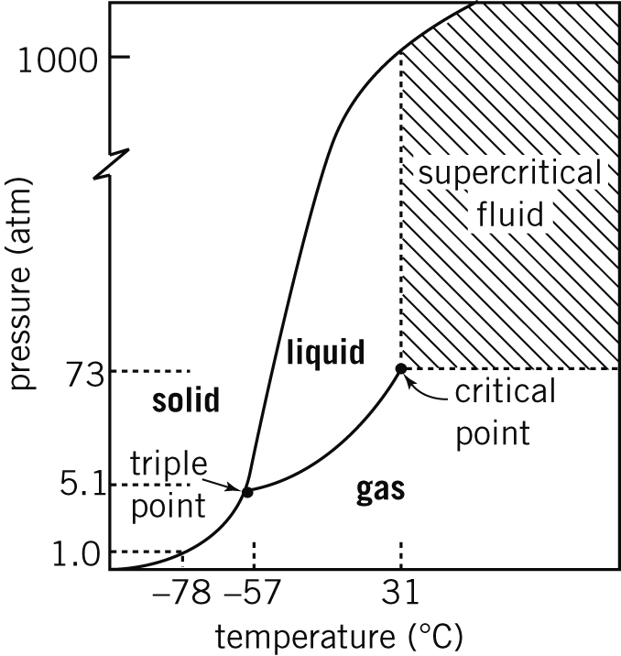

No. | Question | Answer
 | The graph also shows the triple point for carbon dioxide (–57°C and 5 atm). Which three states are present at the tripe point?
By referring to the phase diagram, state what phase changes would be observed if a sample of carbon dioxide gas was:
a cooled to a temperature below the triple point, and then the pressure was increased
b heated to a temperature between the triple point and the critical point, and then the pressure was increased
c heated to a temperature just above the critical point, and then the pressure was increased
d held at atmospheric pressure and cooled to –90°C.

Supercritical fluids show properties of both liquids and gases. They have the unique ability to diffuse through substances like a gas, and dissolve materials like a liquid. They readily change density and viscosity with minor changes in temperature and pressure. Supercritical fluids can therefore be used as solvents. Supercritical fluids exhibit a pressure-dependent dissolving power. The higher the pressure, the higher the dissolving power.
Supercritical carbon dioxide is an excellent non-polar solvent for many organic compounds, and is used to extract flavours and aroma-producing chemicals from hops. Hops are added to beer to add flavours and aromas, and to give beer its bitter taste. Hops themselves are not bitter, but contain compounds that react on heating to produce bitter isomers.

No. | Question | Answer
 | What are isomers?
 | Traditionally, flavours were extracted from hops using water under pressure. Given that the flavour compounds are large organic molecules, suggest why this method was not very efficient.
 | Organic solvents such as ethanol and dichloromethane have also been used for the hop extraction. Suggest one advantage and one disadvantage of using these organic solvents compared to water.

In the extraction of hop flavours using supercritical carbon dioxide, the gas is first compressed to very high pressures and a temperature around 50°C. This supercritical fluid is passed through pelletised hops, where the flavours and oils are dissolved and extracted. The gaseous solution leaves the extractor, and the hop components and carbon dioxide are separated. The carbon dioxide is recycled.

Suggest two advantages of the use of supercritical carbon dioxide compared to organic solvents.

Suggest two disadvantages of the use of supercritical carbon dioxide compared to organic solvents.

Suggest how the hop components and carbon dioxide could be separated.

Investigate another use of supercritical carbon dioxide in the extraction of compounds from food materials. Write a brief account of the method used.

